SmartDevice Functionality

Version 1.0 March 31, 2013

SmartDevices are IOS or Android devices which the user interacts with to control what is being displayed on their display device. It also provides access to additional functions e.g. friends, local, apps, etc.

Terms:

Server: cloud based server infrastructure

Client: roku, ps3 device which connects to internet and display device

SmartDevice: an android, IOS device with which the user interacts with the server

User: a person with an account

Administrator: a member of the UA team who can perform functions on the server

Server – cloud based server infrastructure which serves up images for display

Viewlist – fixed list of images which will be displayed

Release Versions:

0 – basic demo to show to potential investors and device manufacturers

.5 – simple functional system to give to 25 “friends” to play with and give us feedback

1.0 – first system which real users can use

Basic V0 functionality

No native functionality, the user access the UA server by using the native browser on their device

Version .5 Functionality

1. Native android application
2. On application start it shows what is on display for the associated client along with metadata.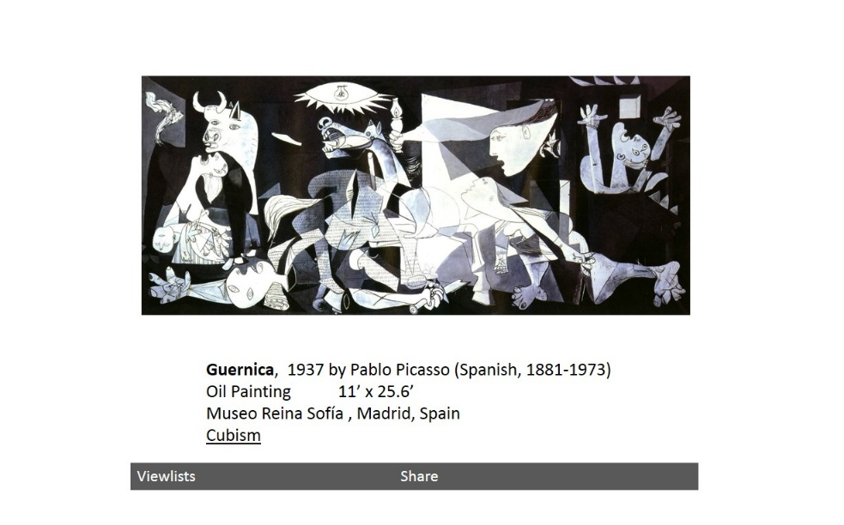
3. The user can swipe left and right to move the change the displayed image forward and backwards through the viewlist
4. The viewlists button brings up the viewlists screens which allows the user to switch to another viewlist

